October 2019 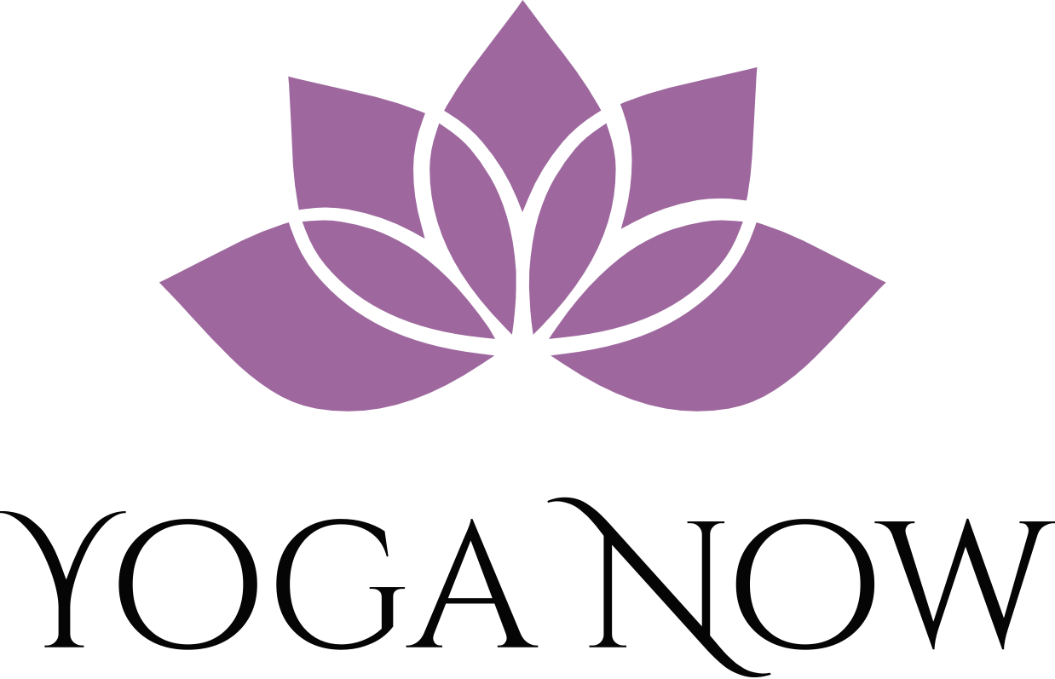 Your Zen Begins Here
Sunday | Monday | Tuesday | Wednesday | Thursday | Friday | Saturday
 |  | 1 | 2 | 3 | 4 | 5
*schedule subject to change, stay tuned to Sunday morning email for most up to date offerings | HAPPY BIRTHDAY YOGA NOW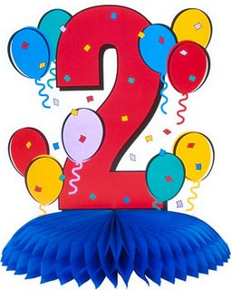 | OUTDOOR ZEN CAMP- 9:15-10:15  YOGA SCULPT- 7-8pm | ALL-LEVELS YOGA-  6:15-7:15am | GENTLE YOGA- Noon-1pm  ALL-LEVELS YOGA- 7-8pm | YOGA SCULPT- 9:15-10:15
6 | 7 | 8 | 9 | 10 | 11 | 12
OUTDOOR ZEN CAMP- 7-8am  YOGA FOR TWEENS-2-3pm | ALL-LEVELS YOGA-  7-8pm  Love and Light Theme | YOGA SCULPT- 10-11am | YOGA SCULPT-  6:15-7:15am | YOGA/PILATES FUSION- Noon-1pm  ZEN CAMP- 7-8pm | ALL-LEVELS YOGA- 9:15-10:15am  Love and Light Theme
13 | 14 | 15 | 16 | 17 | 18 | 19
 |  | ALL-LEVELS YOGA- 9:15-10:15am  ALL-LEVELS YOGA- 7-8pm | ZEN CAMP – 6:15-7:15am | YOGA SCULPT- Noon-1pm  YOGA/PILATES FUSION- 7-8pm | ZEN CAMP- 9:15-10:15am  FREE FLOW FUN FRIDAY- 6-7pm
20 | 21 | 22 | 23 | 24 | 25 | 26
YOGA SCULPT- 7-8am | -  GENTLE YOGA WITH NIDRA- 7-8pm | YOGA SCULPT-10-11am | CARDIO PILATES- 6:15-7:15am | GENTLE YOGA WITH NIDRA- Noon-1pm  ALL-LEVELS YOGA- 7-8pm | ZEN CAMP- 9:15-10:15am
27 | 28 | 29 | 30 | 31
HEALING STONE JEWELRY MAKING  SOCIAL AND HOLIDAY BAZZAR- 4-6pm | HALLOWEEN THEMED  YOUNG YOGIS-  5:15-6pm | ALL-LEVELS YOGA- 9:15-10:15am  YOGA SCULPT-  7-8pm | ALL-LEVELS YOGA- 6:15-7:15am | YOGA/PILATES FUSION- Noon-1pm  ALL-LEVELS YOGA-  7-8pm | YOGA SCULPT- 9:15-10:15am
Yoga Now CLASS DESCRIPTIONS
ALL-LEVELS YOGA- A class that links physical postures, concentrated breathing, and mindfulness in a format appropriate for beginner to advanced yogis. Participants are encouraged to listen to their bodies and take options that work best for their desired yoga experience. Class ends with a relaxation time designed for stillness and reflection.
YOGA/PILATES FUSION- This class includes both classic Pilates exercises and yoga sequences. Pilates is a discipline that like Yoga incorporates breathing, mindfulness and flexibility with an emphasis on building core strength and stabilization. The class finishes with a yoga relaxation. This class is appropriate for all fitness levels.
GENTLE YOGA- A perfect class for those who are new to yoga or want to take their yoga practice a little slower. This class avoids Vinyasa sequences which is the process of linking yoga postures together in a flowing style. This class is soft, nurturing and relaxing. Props are available for support during postures.
ZEN CAMP- A high-intensity exercise class that uses yoga inspired exercises to rev up the heart rate and build strength at a rapid rate. Think of this class as a “blissed-out boot camp” or “power yoga with a little spice”. While this class moves at a faster pace, participants are provided multiple intensity options, opportunities for rest and encouragement to move mindfully. The class concludes with great stretching and a relaxing savasana. This is the best of both worlds for those who want a challenging workout with an element of ZEN.
YOUNG YOGIS- Appropriate for ages 5-12. A class that teaches children breathing and relaxation techniques alongside of super fun and kid friendly postures. Children will be led through short yoga sequences and will also have fun with yoga games and activities like Yogi Memory and the Emoji Yogi.
YOGA SCULPT- This class resembles an All-Levels Yoga class with added emphasis on building strength and muscular endurance. Props like TheraBands, blocks, balls and straps provide extra resistance and toning benefits for the body. Participants are encouraged to work within their own desired level of resistance and may do the movements without the extra resistance as an option.
YOGA FOR TWEENS- This class is appropriate for children between 10-14 years old. It’s a perfect next step for the mature pre-teen that wants a slightly more serious class than the Young Yogis. This class is an approachable and fun version of an All-Levels adult class. This class emphasizes body awareness and appreciation while teaching stress-relieving breath techniques and poses that help promote good posture, core strength and balance.
CARDIO PILATES- Traditional core strengthening exercises sprinkled among cardio intervals designed to get the heart pumping and jump start the metabolism. Multiple intensity options are provided.
October Speciality Classes:
OUTDOOR ZEN CAMP- Zen camp on the move. Participants will enjoy all the fun and hard work of a typical Zen Camp while travelling from station to station outdoors. The class will move along neighborhood trails and tot lots/sports courts with stops along the way for mindful and energetic exercises. Participants should be comfortable with a strong power walk or easy jog and it is recommended to bring water. The class concludes with great stretching and a meditation in nature.
ALL-LEVELS YOGA (Love and Light Theme)- The playlist, readings and poses that make up this All-Levels class will aim to inspire the practitioner to be an expression of love and light for the world.
GENTLE YOGA WITH NIDRA- A slow-paced, soft and nurturing class followed by guided meditation (Nidra) that aims to lead its practitioner to a blissful state of complete physical, mental and emotional relaxation.
FREE FLOW FUN FRIDAY- This class will be full of fun with lots of flow and the best part of all, it’s FREE for everyone. Invite your friends, sign up early and get ready groove and move while we share good vibes among fellow yogis. This class is appropriate for all-levels.
YOUNG YOGIS (Halloween Themed)- Cast the costumes aside and come as you are as we trick or treat for yoga poses and mindful moments. All yogis will also leave with a few non-sugar surprises.
HEALING STONE JEWELRY MAKING SOCIAL AND HOLIDAY BAZAAR- Yogis of all ages (adults and children) are welcome to pop over and put together their own healing stone essential oil diffuser bracelets while enjoying refreshments and fellowship with their good vibe tribe. With the holidays upon us, discounts on jewelry, Refocus Bands, yoga packages, essential oils and other exclusive mindful products will be available. Additional vendors welcome- if you have a service, product, small business you’d like to promote- let me know!

