November 2019 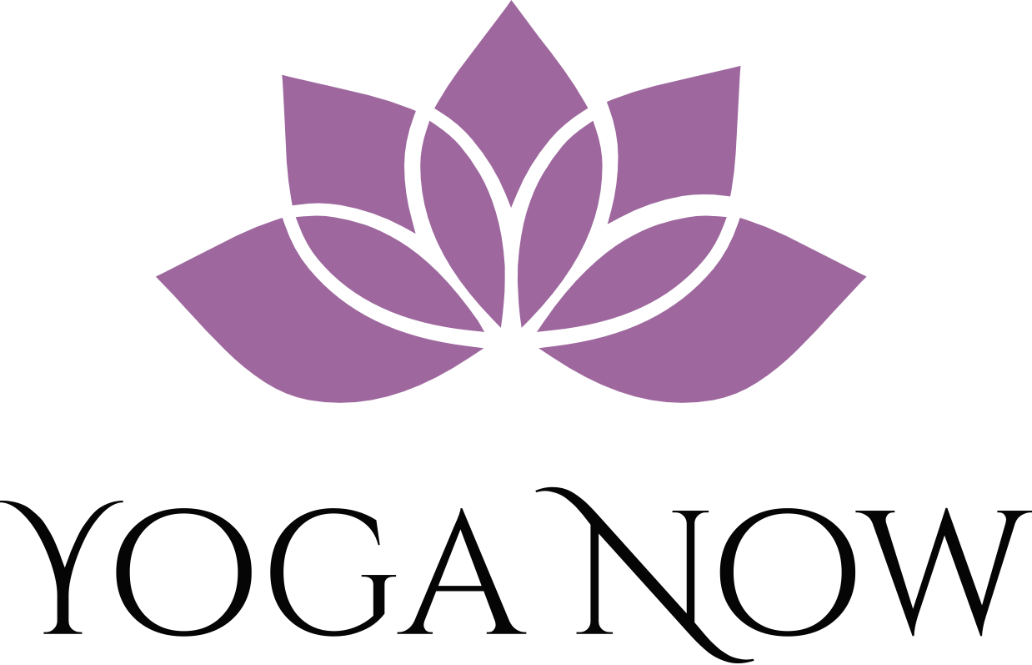 Your Zen Begins Here
Sunday | Monday | Tuesday | Wednesday | Thursday | Friday | Saturday
 |  |  |  |  | 1 | 2
*schedule subject to change, stay tuned to Sunday morning email for most up to date offerings |  |  |  |  | YOGA SCULPT- 9:15-10:15
3 | 4 | 5 | 6 | 7 | 8 | 9
 |  | ALL-LEVELS YOGA- 7-8pm | YOGA SCULPT-  6:15-7:15am  GENTLE YOGA- 7-8pm | ALL-LEVELS YOGA- Noon-1pm | ZEN CAMP- 9:15-10:15am
10 | 11 | 12 | 13 | 14 | 15 | 16
ALL-LEVELS YOGA-  7-8am  COLOR ME CHAKRAS  KIDS WORKSHOP-  2-4pm |  | YOGA SCULPT- 9:15-10:15am  YOGA/PILATES FUSION- 7-8pm | ZEN CAMP – 6:15-7:15am | GENTLE YOGA- Noon-1pm  ALL-LEVELS YOGA- 7-8pm | ALL-LEVELS YOGA- 9:15-10:15am
17 | 18 | 19 | 20 | 21 | 22 | 23
 | - | ZEN CAMP-10-11am  GENTLE YOGA- 7-8pm | ALL-LEVELS YOGA- 6:15-7:15am | YOGA SCULPT- Noon-1pm  ALL-LEVELS YOGA- 7-8pm | YOGA/PILATES FUSION- 9:15-10:15am
24 | 25 | 26 | 27 | 28 | 29 | 30
ALL-LEVELS YOGA-  7-8am |  | GRATITUDE YOGA- 9:15-10:15am  GRATITUDE YOGA-  7-8pm | GRATITUDE ZEN CAMP- 6:15-7:15am | HAPPY THANKSGIVING  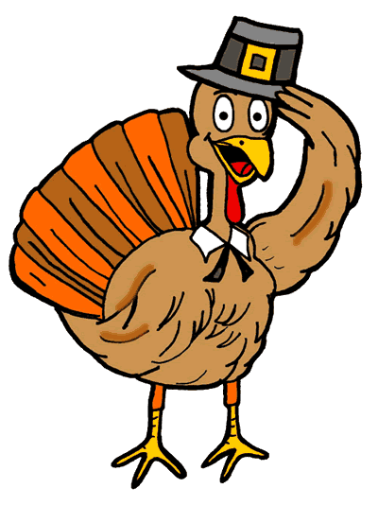 | YOGA SCULPT- 10-11am
Yoga Now CLASS DESCRIPTIONS
ALL-LEVELS YOGA- A class that links physical postures, concentrated breathing, and mindfulness in a format appropriate for beginner to advanced yogis. Participants are encouraged to listen to their bodies and take options that work best for their desired yoga experience. Class ends with a relaxation time designed for stillness and reflection.
YOGA/PILATES FUSION- This class includes both classic Pilates exercises and yoga sequences. Pilates is a discipline that like Yoga incorporates breathing, mindfulness and flexibility with an emphasis on building core strength and stabilization. The class finishes with a yoga relaxation. This class is appropriate for all fitness levels.
GENTLE YOGA- A perfect class for those who are new to yoga or want to take their yoga practice a little slower. This class avoids Vinyasa sequences which is the process of linking yoga postures together in a flowing style. This class is soft, nurturing and relaxing. Props are available for support during postures.
ZEN CAMP- A high-intensity exercise class that uses yoga inspired exercises to rev up the heart rate and build strength at a rapid rate. Think of this class as a “blissed-out boot camp” or “power yoga with a little spice”. While this class moves at a faster pace, participants are provided multiple intensity options, opportunities for rest and encouragement to move mindfully. The class concludes with great stretching and a relaxing savasana. This is the best of both worlds for those who want a challenging workout with an element of ZEN.
YOUNG YOGIS- Appropriate for ages 5-12. A class that teaches children breathing and relaxation techniques alongside of super fun and kid friendly postures. Children will be led through short yoga sequences and will also have fun with yoga games and activities like Yogi Memory and the Emoji Yogi.
YOGA SCULPT- This class resembles an All-Levels Yoga class with added emphasis on building strength and muscular endurance. Props like TheraBands, blocks, balls and straps provide extra resistance and toning benefits for the body. Participants are encouraged to work within their own desired level of resistance and may do the movements without the extra resistance as an option.
YOGA FOR TWEENS- This class is appropriate for children between 10-14 years old. It’s a perfect next step for the mature pre-teen that wants a slightly more serious class than the Young Yogis. This class is an approachable and fun version of an All-Levels adult class. This class emphasizes body awareness and appreciation while teaching stress-relieving breath techniques and poses that help promote good posture, core strength and balance.
CARDIO PILATES- Traditional core strengthening exercises sprinkled among cardio intervals designed to get the heart pumping and jump start the metabolism. Multiple intensity options are provided.

November Speciality Classes:
GRATITUDE YOGA- An All-Levels Yoga class with a playlist, readings and poses that will stimulate feelings of gratitude, love and well-being.

COLOR ME CHAKRAS KIDS WORKSHOP- A 2-hour workshop that will introduce children to the energetic subtle body. Children will learn characteristics of the 7 chakras and their role in our well-being. Through poses, colors, imagery and more, we will explore being grounded (1), flexible (2), determined (3), loving (4), good communicators (5), wise (6) and happy (7). Each child will leave with a Yoga Now original chakra crayon set and coloring book complete with a yoga pose glossary. The cost of this workshop is $25/child. Each additional sibling is $15/child.

